Source https://www.viator.com/tours/Honolulu/Oahu-Dolphin-Snorkel-Cruise-Including-Lunch-and-Activities/d59070-18676P1
__________________________________________________________

Oahu Marine Adventure Cruise: Dolphins, Turtles & Ocean Activities
__________________________________________________________
★★★★★ 4.5/5 20 reviews

Add to wishlist ♡

__________________________________________________________

3.5 Hours | €250 per person

🏕  Image | 🏕  Image | 🏕  Image | 🏕  Image | 🏕  Image | 🏕  Image

__________________________________________________________
Experience Overview
Set sail along Oahu’s scenic coastline for an unforgettable ocean adventure combining wildlife encounters, snorkeling, and onboard water activities. This guided cruise offers the chance to observe dolphins and sea turtles in their natural environment while enjoying a variety of fun experiences such as kayaking, paddleboarding, and a sea slide. With snorkeling equipment provided and lunch included, this excursion blends relaxation, discovery, and excitement into one seamless marine experience.
__________________________________________________________
Tour Snapshot
- Duration: Approx. 3.5 hours
- Meeting Point: Waiʻanae Small Boat Harbor, 85-491 Farrington Hwy, Waianae, Hawaii
- Group Size: Up to 70 travelers
- Accommodation: Not included
- Languages: English, Japanese
- Guide: Professional live guide included
- Transportation: Waikiki hotel pickup available (optional)
- Accessibility: Not wheelchair accessible
- Season: Available year-round
__________________________________________________________

Check Dates & Availability

Select participants: (Age 99 and younger) - 1 +

Choose date:
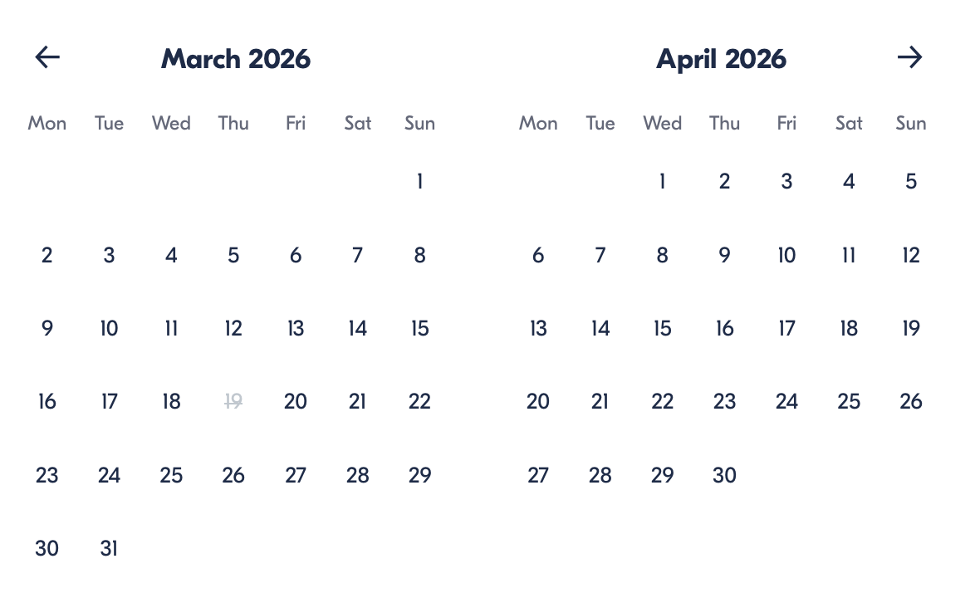

Check Availability

opens:

Participants: 1 March 16, 2026

Oahu Marine Adventure Cruise: Dolphins, Turtles & Ocean Activities

- Experience: Oahu Marine Adventure Cruise
- Duration: 3.5 hours
- Start Times: 7:00 AM / 11:00 AM

Cancellation:

- Free cancellation up to 24 hours before start time

Price breakdown: 1 Participant x €250

Total: €250 per person

The total price includes all taxes and fees.

Add to cart Book now

__________________________________________________________
Key Highlights
- Cruise along Oahu’s coast searching for wild dolphins
- Snorkel among sea turtles and tropical marine life
- Use onboard equipment, including kayaks and paddle boards
- Enjoy a complimentary lunch during the trip
- Experience fun ocean features such as a water slide
__________________________________________________________
Experience Plan

Ocean Wildlife Cruise & Snorkel Experience
Your adventure begins at Waiʻanae Harbor, where you’ll board your vessel and head out into Oahu’s vibrant coastal waters. The first highlight is spotting dolphins in their natural habitat — a truly magical encounter when they appear near the boat. Afterward, you’ll stop at a snorkeling location where you can swim among sea turtles and colorful marine life using the provided gear.
Between water sessions, relax onboard with lunch and take advantage of additional activities such as paddleboarding, kayaking, or sliding directly into the ocean from the boat’s sea slide. The experience concludes with return transportation to your hotel if pickup was selected.
Accommodation:
Not included (activity experience only)
__________________________________________________________
Included in Price
- Snorkeling equipment (mask, fins, snorkel)
- Safety flotation devices
- Kayaks and paddle boards
- Water slide access
- Complimentary lunch (choice of sandwich options)
- Optional hotel pickup and return
- Guided cruise experience
__________________________________________________________
Not Included
- Wetsuit rental
- Professional photos
- Gratuities for crew
- Outside alcoholic beverages
__________________________________________________________
Traveler Suitability
This excursion is suitable for most travelers, but is not recommended for:
- Children under 2 years old
- Guests with serious heart conditions or major medical issues
- Wheelchair users
Children aged 2–11 must be accompanied by an adult.
__________________________________________________________
Important Trip Information
- Confirmation: Provided immediately after booking.
- Wildlife Notice: Dolphin sightings are common but cannot be guaranteed.
- Arrival Advice: Guests driving independently should allow about one hour from Waikiki to the harbor.
- Boarding Note: Shoes must be removed before boarding.
- Capacity: Maximum 70 participants.
__________________________________________________________

Cancellation Policy
Free cancellation is available if canceled at least 24 hours before the start time.
- Cancel ≥ 24 hours → Full refund
- Cancel < 24 hours → No refund
- Changes within 24 hours → Not accepted
If the experience is canceled due to bad weather or insufficient participants, you’ll be offered a different date or a full refund.

__________________________________________________________
Guest Reviews

Overall rating  4.5/5  ★★★★★  Based on 20 reviews | Review summary  Guide 4.5/5  Transportation 4.6/5  Service 4.7/5  Organisation 4.5/5

Filter  - All traveller types  - Couples  - Group of friends  - Families  By star rating  - All star ratings  - 5 stars  - 4 stars  - 3 stars  - 2 stars  - 1 star | Search reviews (e.g., guide)  Sort by:  - Top picks  - Latest reviews  - Best ratings  - Lowest ratings
__________________________________________________________
★★★★★
Daniel R. – Italy
An incredible ocean adventure. Seeing dolphins in the wild and snorkeling with turtles made this one of the best experiences of our trip.
★★★★☆
Carlos M. – Spain
Great excursion with lots of activities. The wildlife sightings were amazing, though I would have liked a bit more time in the water.
★★★★★
Anna W. – Germany
Absolutely fantastic tour. The crew was friendly, the equipment was great, and the whole experience felt well-organized and exciting.
See more reviews
__________________________________________________________

Meta tags

Page - Oahu Marine Adventure Cruise: Dolphins, Turtles & Ocean Activities

Title: Family Winter Adventure Tour in Iceland | Travellio Global

Description: Embark on a 6-day family-friendly adventure through Iceland’s stunning landscapes. Explore waterfalls, geothermal spas, the Golden Circle, and more with your private guide. Ideal for families with children.

H1 - Oahu Marine Adventure Cruise: Dolphins, Turtles & Ocean Activities

__________________________________________________________

